Final Report

for

Hotel Management System

Version 1.0 approved

Prepared by Group-3

Riphah International University, Islamabad

21st September, 2024

**Proposal**

**Project Title:** Hotel Management System

**Description:** Our Hotel Management System is designed to streamline operations and enhance guest satisfaction through a seamless digital platform. It offers features like smart room reservations, personalized services, and easy management of guest records. With a focus on user experience, this system simplifies hotel processes for both staff and customers.

This project introduces dynamic subscription plans and an exclusive membership program, not present in earlier versions. Additionally, the interactive mapping system helps guests navigate the hotel with ease, offering a modern touch. Enhanced security protocols in the login and registration system make it more robust than ever before.

**Features:**

**Smart Room Booking & Reservation:** Allows guests to conveniently book rooms online with real-time availability checks.

**Personalized Meal Ordering:** Offers guests a tailored meal ordering experience directly to their rooms with custom options.

**Hassle-Free Room Cancellation:** Provides an easy and flexible room cancellation system with instant notifications.

**Interactive Hotel Mapping:** Displays hotel layout and services on an interactive map for easier navigation.

**Dynamic Subscription Plans:** Offers customizable subscription packages for recurring guests or long-term stays.

**Exclusive Membership Benefits:** Rewards loyal customers with a membership program offering exclusive discounts and perks.

**Secure Login System:** Provides a secure, password-protected login for guests and hotel staff.

**Seamless Registration Process:** Streamlines guest registration with easy onboarding and profile creation.

**Guest Feedback & Suggestions:** Allows guests to provide feedback or suggestions to enhance their stay experience.

**Comprehensive Record Management:** Maintains detailed records of bookings, payments, and guest preferences for future reference.

Table of Contents

Revision History ii

1. Introduction 1

1.1 Purpose 1

1.2 Project Scope 1

1.3 References 1

2. Overall Description 1

2.1 Product Perspective 1

2.2 User Classes and Characteristics 1

2.3 Operating Environment 2

2.4 User Documentation 2

2.5 Assumptions and Dependencies 2

3. System Features-Functional Requirements 2

3.1 Smart Room Booking & Reservation 3

3.2 Personalized Meal Ordering 3

3.3 Hassle Free Room Cancellation 4

3.4 Interactive Hotel Mapping 4

3.5 Dynamic Subscription Plans 5

3.6 Exclusive Membership Benefits 5

3.7 Secure Login System 6

3.8 Seamless Registration Process 6

3.9 Guest Feedback & Suggestions 7

3.10 Comprehensive Record Management 7

4. Other Nonfunctional Requirements 8

4.1 Performance Requirements 8

4.2 Safety Requirements 8

4.3 Security Requirements 8

Revision History

|  |  |  |  |
| --- | --- | --- | --- |
| **Name** | **Date** | **Reason For Changes** | **Version** |
| Saira Kousar  Aleena Saeed  Aliza Shahid  Jaweria Shehzadi  Motashma Noor | 21/9/24 | Initial draft | 1.0 draft 1 |
|  |  |  |  |

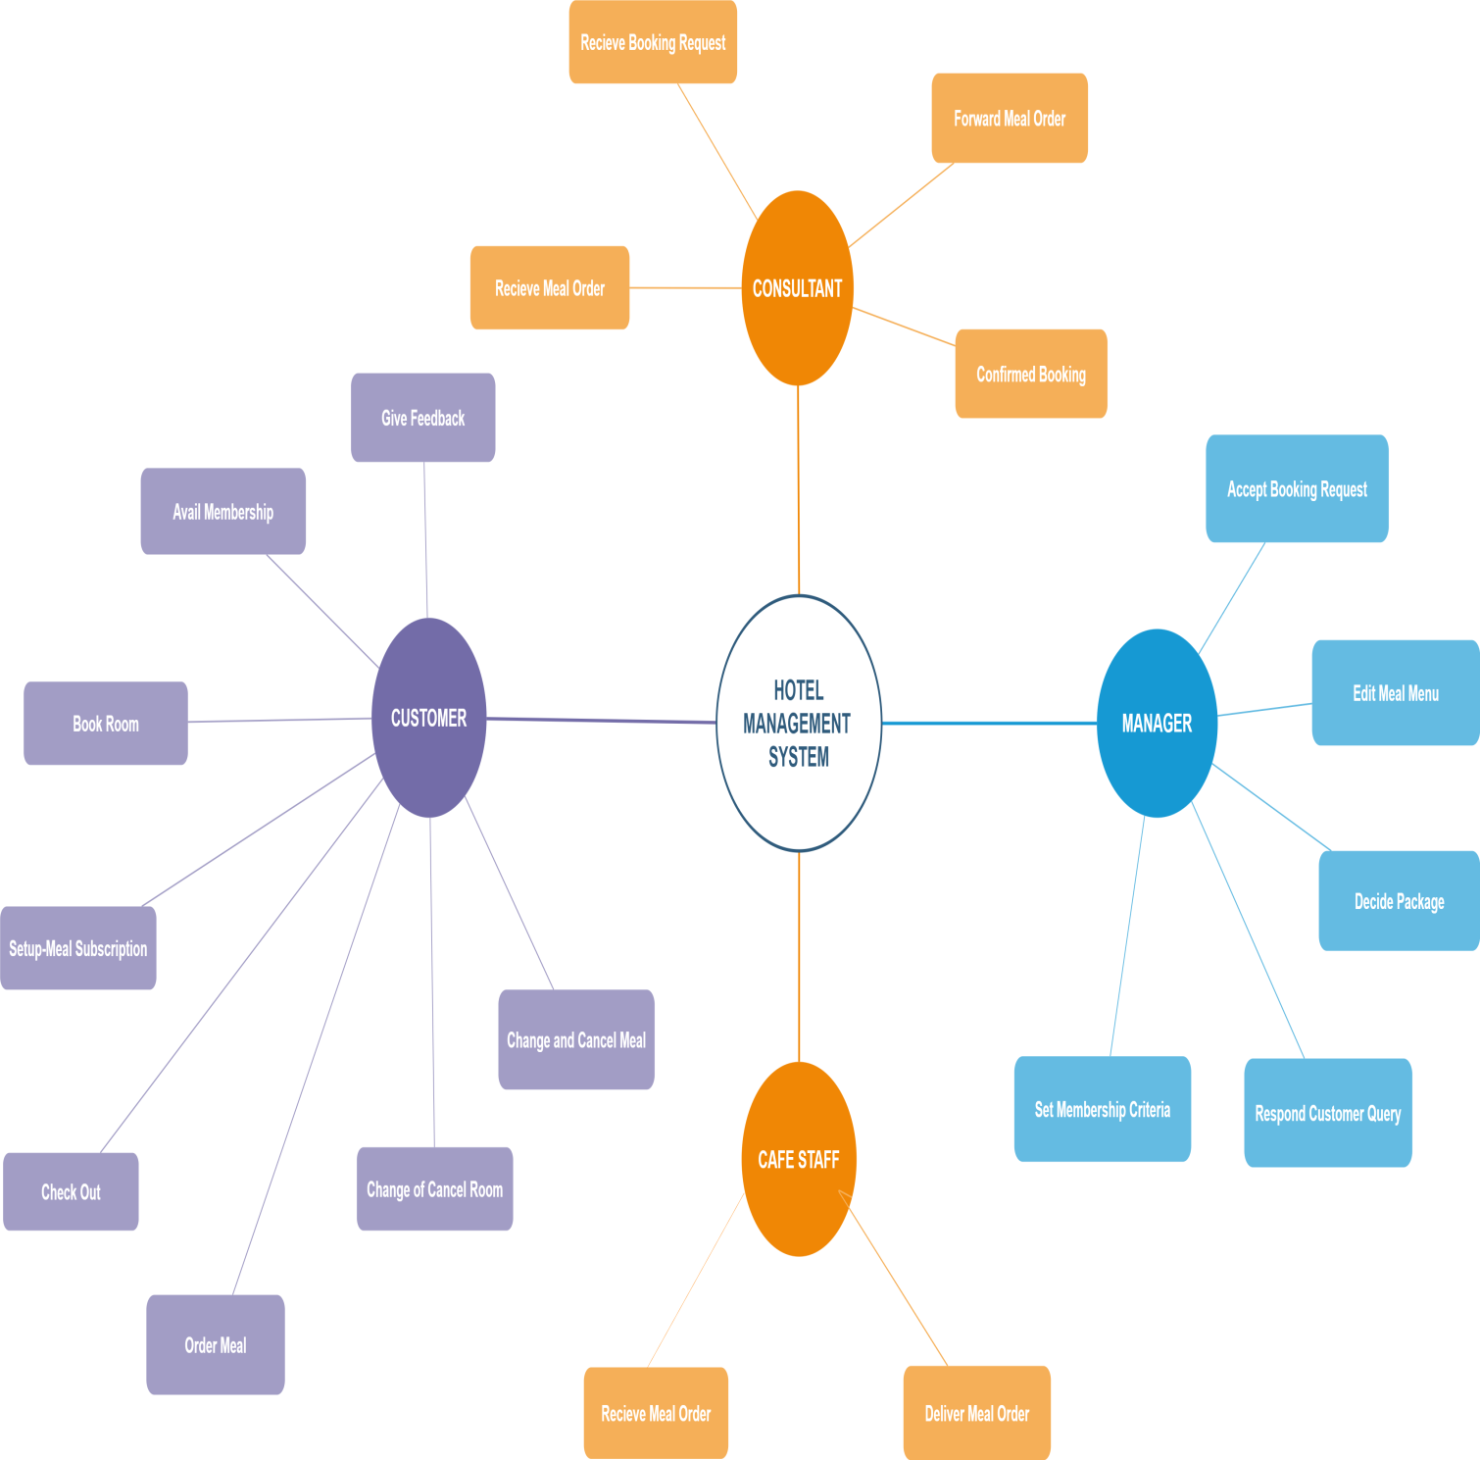

# Introduction

## Purpose

This SRS will provide a detailed description of Hotel Management System (HMS).It will provide a complete understanding of the requirements of this system. . The clear description of the HMS and its’ functionality will allow the accurate development of the software for the end user and all future stages of the project. From this SRS, the HMS can be analyzed, designed, constructed, tested and modified if required. This document is to be used by team members who will implement this project and verify it if there is any need.

## Project Scope

The system we are to develop can be used to digitize the rooms booking procedure by recording the details of the customers & suggesting them room according to their range. The system can search for an appropriate room for customers compatible to their range, services they need and their time of stay. This system will be accessible any time. It can cater multiple customers in shortest of time & with same efficiency. It will help customer in choosing a room by displaying its features and charges per day. System that would automate and ease the workload of the staff of a well-known hotel and provides an easy access to the customers to choose the hotel according to their need and range .System will calculate the bill for customer showing details of facilities used & their charges. This will aid in developing the confidence of customers at the time of payment. This not only aid to the reputation of the city but easy and well managed system provides a good environment to the staff and the employees as well.

## References

1. Shaz. *Hotel Management System*, www.conceptdraw.com
2. Charles. *Hotel Management System,*www.academia.edu.com

# Overall Description

## Product Perspective

The Hotel Management System is a self-contained system that will automate the management system of a new hotel. It will replace the manual and telephonic management of customer registrations, subscriptions, memberships, rooms, meals and other services. The System is expected to provide a complete automation of the previous manual processes till date.

## User Classes and Characteristics

|  |  |
| --- | --- |
| **Customer** | A Customer is a guest in hotel who wishes to book rooms, check-out, order meals, use other facilities of the hotel, give suggestions and feedback. There are about 600 rooms available. Customers can avail memberships and some may wish to set up subscriptions for meal ordering. A customer have the choice to change the room,cancel the room,change and cancel the meals orders, avail other services provided the hotel and give feedback over it. |
| **Consultant** | The hotel will appoint a consultant who will receive requests from the Hotel management System, receive meal orders, forward the orders to ,confirm the booking and order requests. Consultant will need to be trained in the use of the computer, the Web browser, and the HMS. |
| **Manager** | The Manager is responsible for accepting the booking requests from the receptionist. He will decide the membership’s criteria, subscriptions. He will receive queries from the customers and generate response to it.The manager will decide the packages and other services available for the customers. The Manager can edit the menus for meals that are not available or price changes. |
| **Cafe Staff** | Staff will receive the online orders of meals from the customer. Prepare the order and deliver. |

## Operating Environment

OE-1: The Hotel Management System shall operate with the following Web browsers:

Mozilla Firefox version 10,Microsoft Internet Explorer versions 5.0 and 6.0, Opera version 8.

OE-2: The Hotel Management System shall operate on a server running the current corporate approved versions of Red Hat Linux and Apache WebServer.

## User Documentation

UD-1: A user manual with illustrated features of the system shall be provided along with the software. It will provide a written instructions on how to navigate and use the system.

UD-2: For the new accessors an online help portal facility will be provided through which the staff can communicate with the users to help them use the system.

UD-3: The System will provide an online tutorial to help the users to book a room, order meal or use any of the functions.

## Assumptions and Dependencies

AS-1: The Hotel will be open 24/7.

DE-1: The registrations, subscriptions and memberships functions of HMS depends on the approval of the management of the Hotel.

DE-2: The ordering facilities depends on changes being made in the Cafeteria Inventory System to update the availability of food items as COS orders are accepted.

# System Features­­-Functional Requirements

## Smart Room Booking & Reservation

|  |
| --- |
| FR-3.1.1: The system displays the reservation option.  FR-3.1.2: The system shall confirm that the customer is registered or not.  FR-3.1.3: If the user is not registered the system will provide a registration option and the quit option.  FR-3.1.4: If the user selects registrations, the system prompts the user to enter the details.  FR-3.1.5: System displays the rooms according to their prices and facilities available with them. |
| FR-3.1.6: The system prompts the user to select a room.  FR-3.1.7: If there is no room available, the system displays message that no room available right now.  FR-3.1.8: If the room is available, the system demands the check-In date and check-out date.  FR-3.1.9: System asks for extra facilities to be availed by the customer. |
| FR-3.1.10: The system calculates and display the total bill according to the days of stay and facilities availed by the customer.  FR-3.1.11: The system shall allow reservations to be modified without having to re-enter all the customer information.  FR-3.1.12: The system demands confirmation from the Customer to reserve a room.  FR-3.1.13: The system shall generate a unique confirmation number for each reservation.  FR-3.1.14: The system shall provide a reservation option for events such as birthday.  FR-3.1.15: The system shall records the customer details.  FR-3.1.16: The system provides option to change the room within 1 day of check-In.  FR-3.1.17: The system allows to modify room selected.  FR-3.1.18: The system demands the reason to change the room.  FR-3.1.19: The system asks for suggestions. |

## Personalized Meal Ordering

|  |
| --- |
| FR-3.2.1: The system shall let the Customer who is logged into the HMS place an order for one or more meals.  FR-3.2.2: The system shall confirm that the Customer is registered for HMS to place an order.  FR-3.2.3: If the Customer is not registered, the system shall give the options to register now and continue placing an order, or to exit from the HMS.  FR-3.2.4: If the Customer is registered, the System displays the menu to the Customer for the day.  FR-3.2.5: The menu also display a brief description of the item. |
| FR-3.2.6: Systems provides the option to select meal and its quantity.  FR-3.2.7: The system shall prompt the Customer for the meal time.  FR-3.2.8: The Customer shall specify whether the order is to be picked up or delivered to the room.  FR-3.2.9: If the order is to be delivered ,the Customer shall provide room number. |
| FR-3.2.10: The Customer may either change the meal time or cancel the order.  FR-3.2.11: The system shall calculate the bill of the meal ordered.  FR-3.2.12: The system shall record the payment of order meal.  FR-3.2.13: The kitchen staff and the hotel owner will receive the list of items order by the respective customer.  FR-3.2.14: The system shall display a total bill of order meal.  FR-3.2.15: The list of items of ordered meal is confirmed and update. |

## Hassle Free Room Cancellation

|  |
| --- |
| FR-3.3.1: The system displays the cancellation option.  FR-3.3.2: The system shall confirm that the customer is checked in or not.  FR-3.3.3: If not, the system shall display the message that you are not checked-in.  FR-3.3.4: The system demands the room no.  FR-3.3.5: The system demand the check-in date and number of stay (if any).  FR-3.3.6: The system shall display the occupancy of room.  FR-3.3.7: The system shall demand the reason for cancellation.  FR-3.3.8: The system shall display the option to change the room  FR-3.3.9: The system display the total bill generated.  FR-3.3.10: The system shall allow the deletion of room. |

## Interactive Hotel Mapping

|  |
| --- |
| FR-3.4.1: The system displays the Maps option.  FR-3.4.2: The system shall confirm that the customer has enabled GPS.  FR-3.4.3: If not, the system shall display the message to connect to the internet and GPS.  FR-3.4.4: The system checks the location of the Customer.  FR-3.4.5: The system displays the nearest branches of hotel.  FR-3.4.6: The system shall display directions to reach the nearest destination.  FR-3.4.7: The system shall display the time to reach there while walking, driving.  FR-3.4.8: The system shall display the current condition of the traffic.  FR-3.4.9: The system display the contact number if the network connection is weak.  FR-3.4.10: The system shall display the reference address of some famous institutes for the sake of ease to find the destination. |

## Dynamic Subscription Plans

|  |
| --- |
| FR-3.5.1: The system displays the subscription option.  FR-3.5.2: The system shall confirm that the customer is logged in.  FR-3.5.3: If not, the system shall display the message to login first.  FR-3.5.4: When customer press the subscribe button, its email is saved in the records.  FR-3.5.5: Notifications regarding new packages are send to the subscribed customer.  FR-3.5.6: The system provides the unsubscribe option.  FR-3.5.7: If unsubscribed, no more notifications will be sent to the customers.  FR-3.5.8: Email will be discarded from the records.  FR-3.5.9: System demands a reason for unsubscription.  FR-3.5.10: System provide the suggestions option to the customer to improve the service. |

## Exclusive Membership Benefits

|  |
| --- |
| FR-3.6.1: The system displays the membership option.  FR-3.6.2: The system shall confirm that the customer is registered.  FR-3.6.3: If not, the system shall display the message to register first.  FR-3.6.4: The system shall confirm that the customer is logged in.  FR-3.6.5: If not, the system shall display the message to login first.  FR-3.6.6: The system displays the membership packages, discounts.  FR-3.6.7: The system displays the special discount for birthdays for its members.  FR-3.6.8: System displays the limit for membership.  FR-3.6.9: System provides the option to renew the membership package and give special discount with it.  FR-3.6.10: The system demands a confirmation from the customer to avail memberships.  FR-3.6.11: System provides the facility that if customer avail 10 reservations , its membership renewal is free and automatic.  FR-3.6.12: System provides option to discard the membership.  FR-3.6.13: System demands a reason for discarding membership. |

## Secure Login System

|  |
| --- |
| FR-3.7.1: The system displays the login option.  FR-3.7.2: The system shall confirm that the user is registered.  FR-3.7.3: If not, the system shall display the message to register.  FR-3.7.4: The system demands the username and password of user.  FR-3.7.5: The system provides the login button.  FR-3.7.6: The system checks whether the username is correct.  FR-3.7.7: If not, system won’t grant access to the user and provide option to re-enter correct username.  FR-3.7.8: The system checks whether the password is correct.  FR-3.7.9: System blocks the account if password is entered wrong 3 times.  FR-3.7.10: The system displays the time duration after logged in.  FR-3.7.11: The system shall log out automatically when after timed out. |

## Seamless Registration Process

|  |
| --- |
| FR-3.8.1: The system displays the registration option.  FR-3.8.2: The system provides the video tutorials for the users on how to register.  FR-3.8.3: The system shall demand the details of the customer.  FR-3.8.4: System provides a form to fill for the information.  FR-3.8.5: The system provides the option to modify any detail without filling the whole form.  FR-3.8.6: System will acknowledge the user if any required field is missed out.  FR-3.8.7: The system ensures from the customer that the information entered is correct.  FR-3.8.8: System provides the submit option.  FR-3.8.9: System provides the option to modify the details even after submitted.  FR-3.8.10: System displays the form to user after submission.  FR-3.8.11: System saves the information of the customer in records.  FR-3.8.12: System provides an option to unregister.  FR-3.8.13: System demands a reason to cancel registration.  FR-3.8.14: Once registered, system provides an option to login to the account. |

## Guest Feedback & Suggestions

|  |
| --- |
| FR-3.9.1: The system displays the suggestions option.  FR-3.9.2: The system shall confirm that the Customer is logged in.  FR-3.9.3: If not, the system shall display the message to login.  FR-3.9.4: The system provides a text field to enter suggestions.  FR-3.9.5: The system provides the submit button.  FR-3.9.6: The system saves and deliever the suggestion to the management.  FR-3.9.7: System provides the facility to the manager to reply to the comment.  FR-3.9.8: The system provides the option to erase the suggestions. |

## Comprehensive Record Management

|  |
| --- |
| FR-3.10.1: The system shows the records option to the admin.  FR-3.10.2: The system shall demand the details of the customer.  FR-3.10.3: System provides a form to fill for the information.  FR-3.10.4: System will acknowledge the user if any required field is missed out.  FR-3.10.5: The system ensures from the customer that the information entered is correct.  FR-3.10.6: System provides the submit option.  FR-3.10.7: When submitted, the system saves the information in records of HMS.  FR-3.10.8: System provides the option to modify the details even after submitted.  FR-3.10.9: System displays the form to admin after submission.  FR-3.10.10: System displays and prints the entire details of the customers stay in the hotel.  FR-3.10.11: System grant access of the records only to the admin.  FR-3.10.12: System allows to navigate through the records by entering the name or contact number of the customer. |

# Other Nonfunctional Requirements

## Performance Requirements

PE-1: The system shall accommodate 500 customers during any time

PE-2: The load time for user interface screens shall take no longer than two

Seconds means it is too much efficient.

PE-3: The log in information shall be verified within five and customer receive a verified email after submit details.

PE-4: Queries shall return results within five seconds through proper tutorial and page also give you facility to read previous queries and there solution as well.

## Safety Requirements

## Customers and Managers will be able to log in to the Hotel Management System. Customers will have access to the Reservation/Booking. Managers will have access to the Management subsystem as well as the Reservation/Booking. Access to the various subsystems will be protected by a user log in screen that requires a user name and password in this way system provide proper security to their customer. Backup insure database security.

## 4.3 Security Requirements

SE-1: All financial information or personally identifiable information shall be secure

SE-2: Users need to be log in to the Hotel Management System for all operations except viewing a complete hotel information.

SE-3: Customers shall log in according to the access policy.

SE-4: The system shall permit only hotel staff members who are Managers to edit hotel rules and regulations.

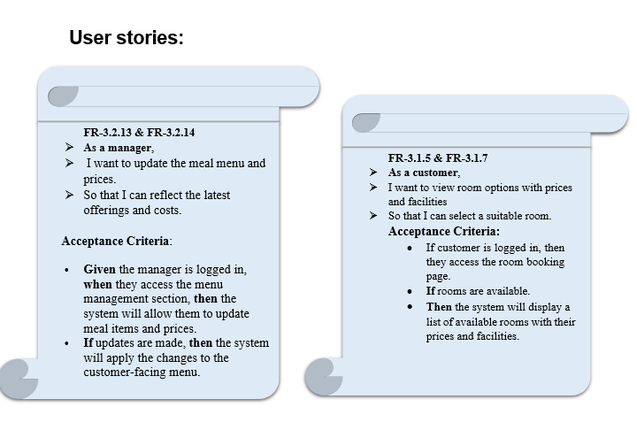

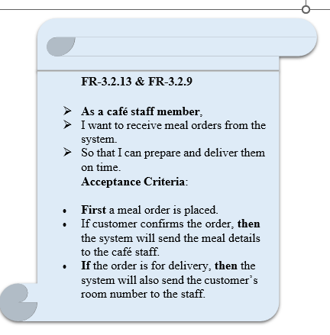

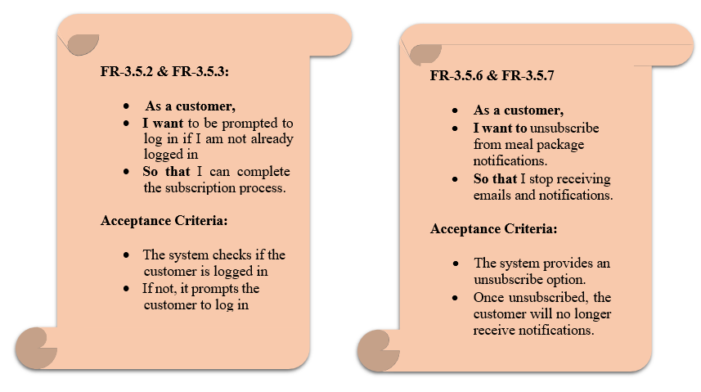

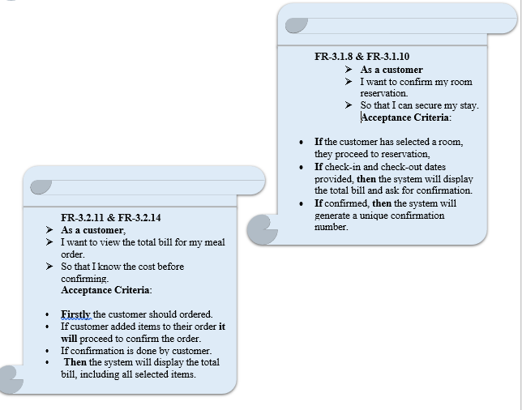



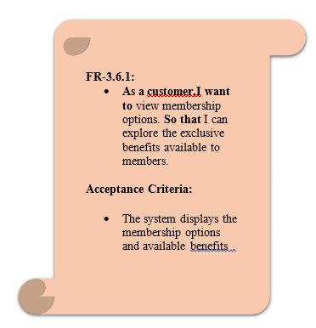

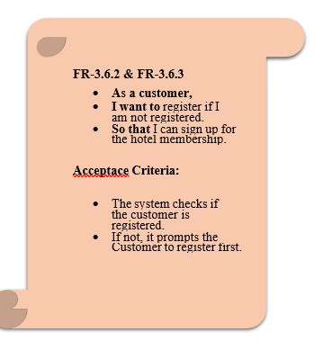

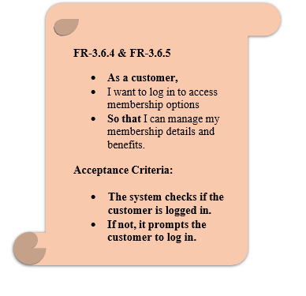

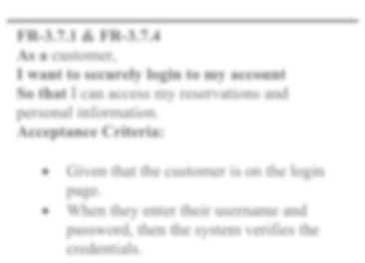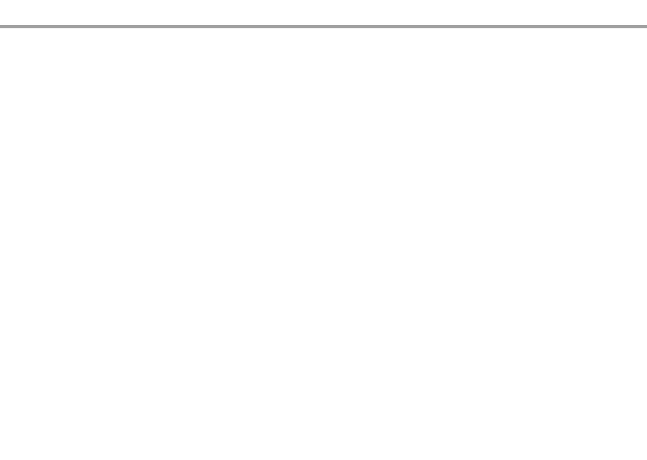

**FR-3.7.1 & FR-3.7.4**

**As a** customer,

**I want to securely login to my account So that** I can access my reservations and personal information.

**Acceptance Criteria:**

* Given that the customer is on the login page.
* When they enter their username and password, then the system verifies the credentials.

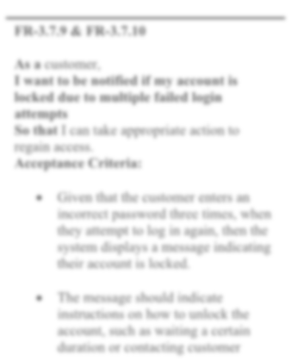

**FR-3.7.9 & FR-3.7.10**

**As a** customer,

**I want to be notified if my account is locked due to multiple failed login attempts**

**So that** I can take appropriate action to regain access.

**Acceptance Criteria:**

* Given that the customer enters an incorrect password three times, when they attempt to log in again, then the system displays a message indicating their account is locked.
* The message should indicate instructions on how to unlock the account, such as waiting a certain duration or contacting customer

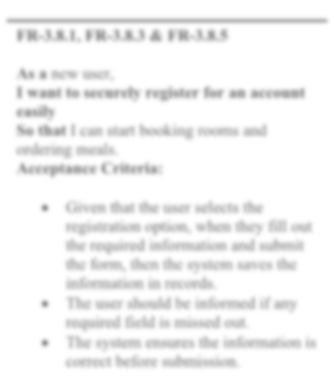

**FR-3.8.1, FR-3.8.3 & FR-3.8.5**

**As a** new user,

**I want to securely register for an account easily**

**So that** I can start booking rooms and ordering meals.

**Acceptance Criteria:**

* Given that the user selects the registration option, when they fill out the required information and submit the form, then the system saves the information in records.
* The user should be informed if any required field is missed out.
* The system ensures the information is correct before submission.

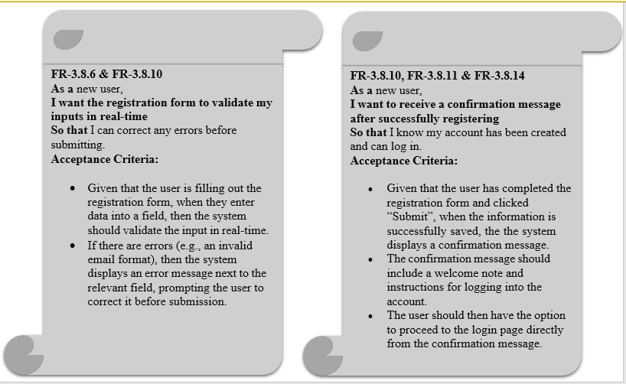

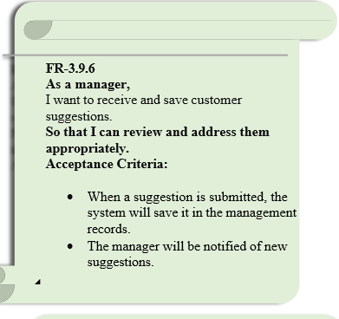

By Motashma Noor

